Welcome to the thingSoC® Grovey One
The TSOC_GROVEY_ONE is an Arduino Uno compatible board, based on the Atmel ATMEGA328P chip, in an Embedded Module format for the new thingSoC, Internet of Things open source hardware standard.
Getting Started :
The TSOC_GROVEY_ONE is very flexible, and there are a number of different ways to power and
reprogram the board, including using a thingSoC USBUART, or other "FTDI" type USB to UART adapters, as well as JTAG/SWD/SPI interfaces for "bare metal" programming.
Using a Li-Po Battery or Wall Power (5V) Adapter :
1) Set the VCC Jumper (Jx) to 3.3 Volts (left position as shown)
2) Using either a thingSoC USB power cable, connect a 5V power source to the Grovey One
as shown below :
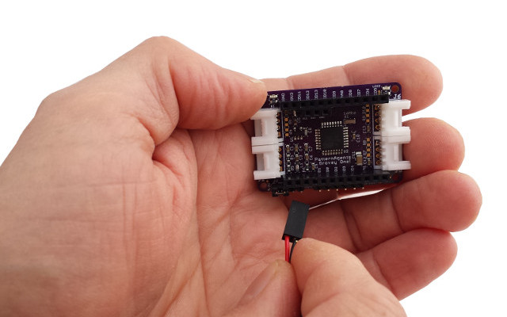
3) Note that this is the prefered combination for using 3.3 Volt Grove and Mikrobus peripherals,
as it provides the correct voltage levels for all 3.3 Volt peripherals.
4) LED2 will illuminate (indicating VCC is powered), and LED1 (D13) will begin to blink slowly.
Using a Standard "FTDI" USB to UART Adapter :
1) Set the VCC Jumper (Jx) to either 3.3 Volts (bottom position)
or 5.0 Volt (top position) depending on you choice of peripherals.
Note that you can't mix voltages, the system is either 3.3 Volts or 5.0 Volts on ALL pins.
2) Plug an "FTDI" type USB to UART into the Grovey One such as the
Sparkfun 5.0 Volt "FTDI Basic" for 5.0 Volt VCC, or the
Sparkfun 3.3 Volt "FTDI Basic" for 3.3 Volt VCC,
and connect the USB cable to your computer.
Note that we use a six (6) pin right angle connector below, or you can just plug it in vertically.
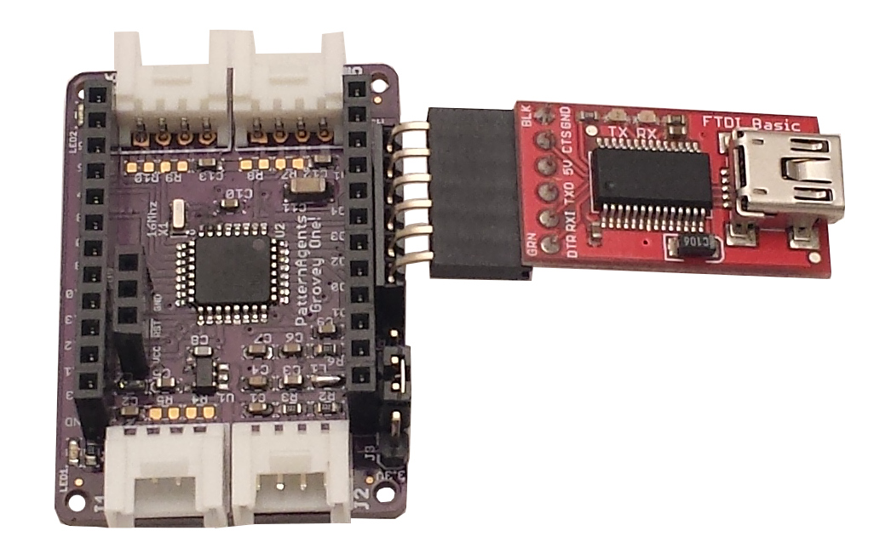
3) In the Arduino IDE, select the "Tools -> Board" type as "Arduino Pro or Pro Mini"
4) In the Arduino IDE, select the "Tools -> Processor" type as either
"ATMEGA328 5V 16Mhz" or "ATMEGA328 3.3V 8Mhz" depending on your VCC jumper setting.
5) In the Arduino IDE, select the "Tools -> Port" as COMx: where X is your FTDI adapter.
6) Now you are ready to program your Grovey One using the Arduino IDE.

Using an ICSP Programmer for Bare Metal Programming :

The TSOC_GROVEY_ONE board comes preloaded with the OPTIBOOT bootloader for Arduino,
but if you prefer to do bare metal programming, connect an ICSP programmer as shown below.
NOTE: the pinout is NOT the same as the default Arduino Pro board (due to space limitations).
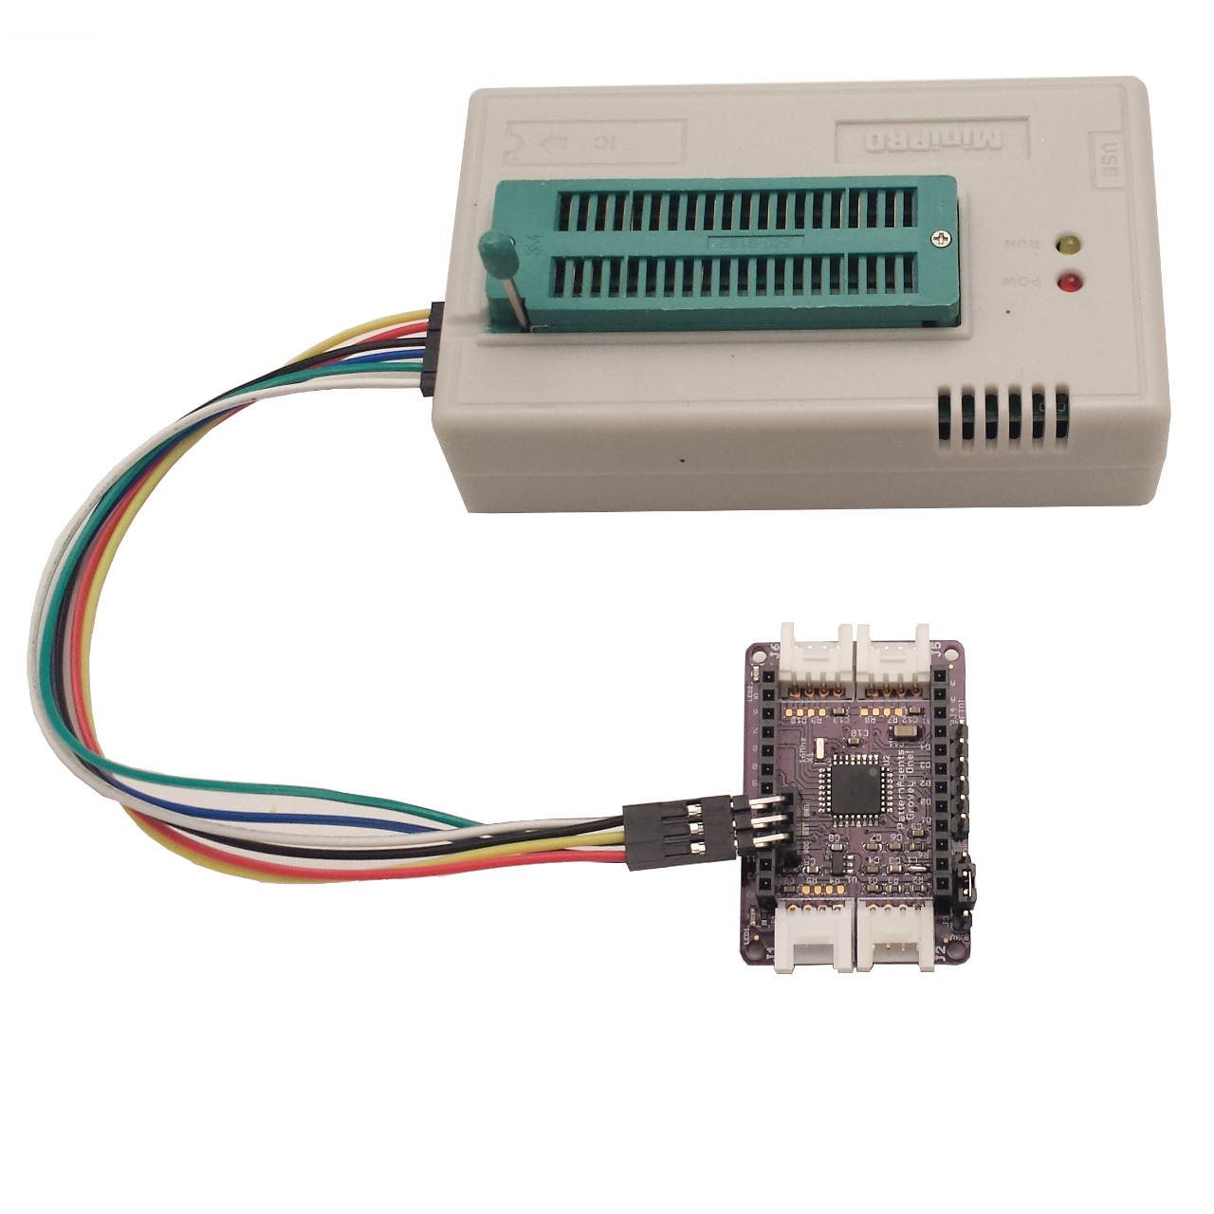
Grovey One
ICSP Pinout
----------------------
| VCC - | - D11 |
| RST - | - D12 |
| GND - | - D13 |
----------------------
Safe Handling Precautions :
1) Always remove/unplug all power before inserting or removing peripherals.
2) Always ground yourself by touching a ground point before handling your boards.
3) Use a static safe bag when transporting your TSOC_GROVEY_ONE board.
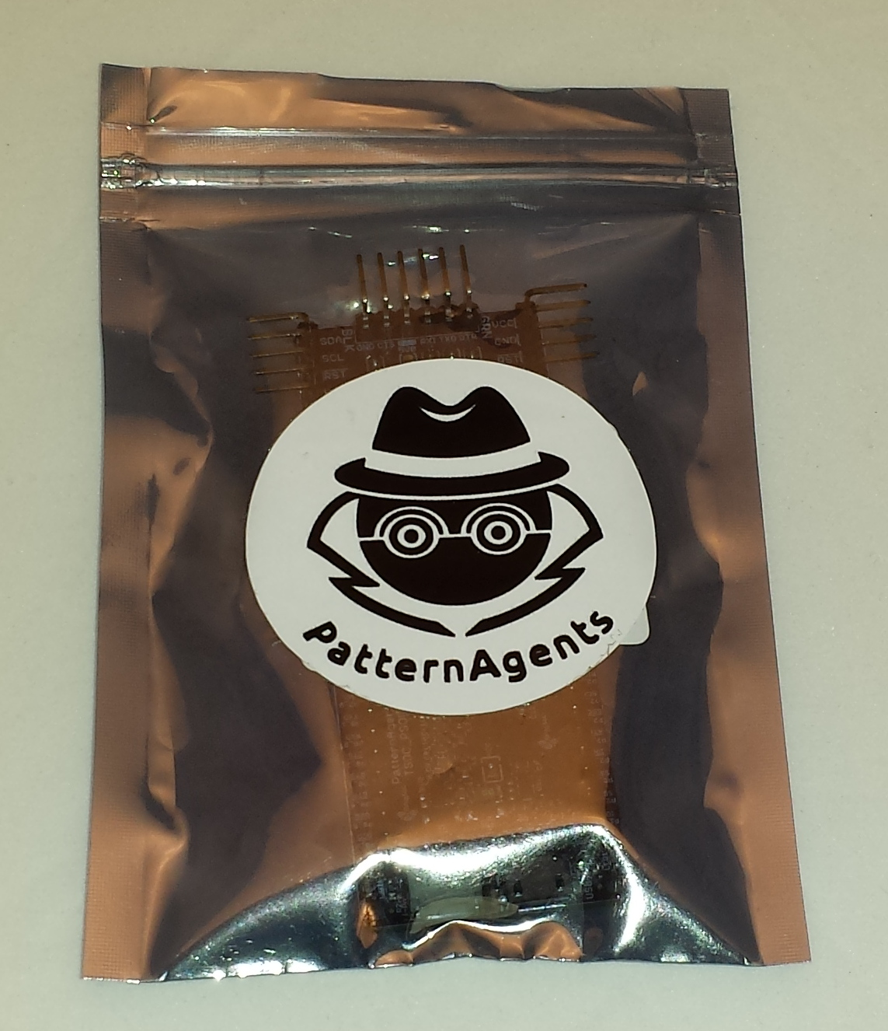

Adding Grove Peripherals :
The TSOC_GROVEY_ONE board supports both Grove and Mikrobus peripherals.
1) Grove connectors are polarized, and can only be plugged in one way.
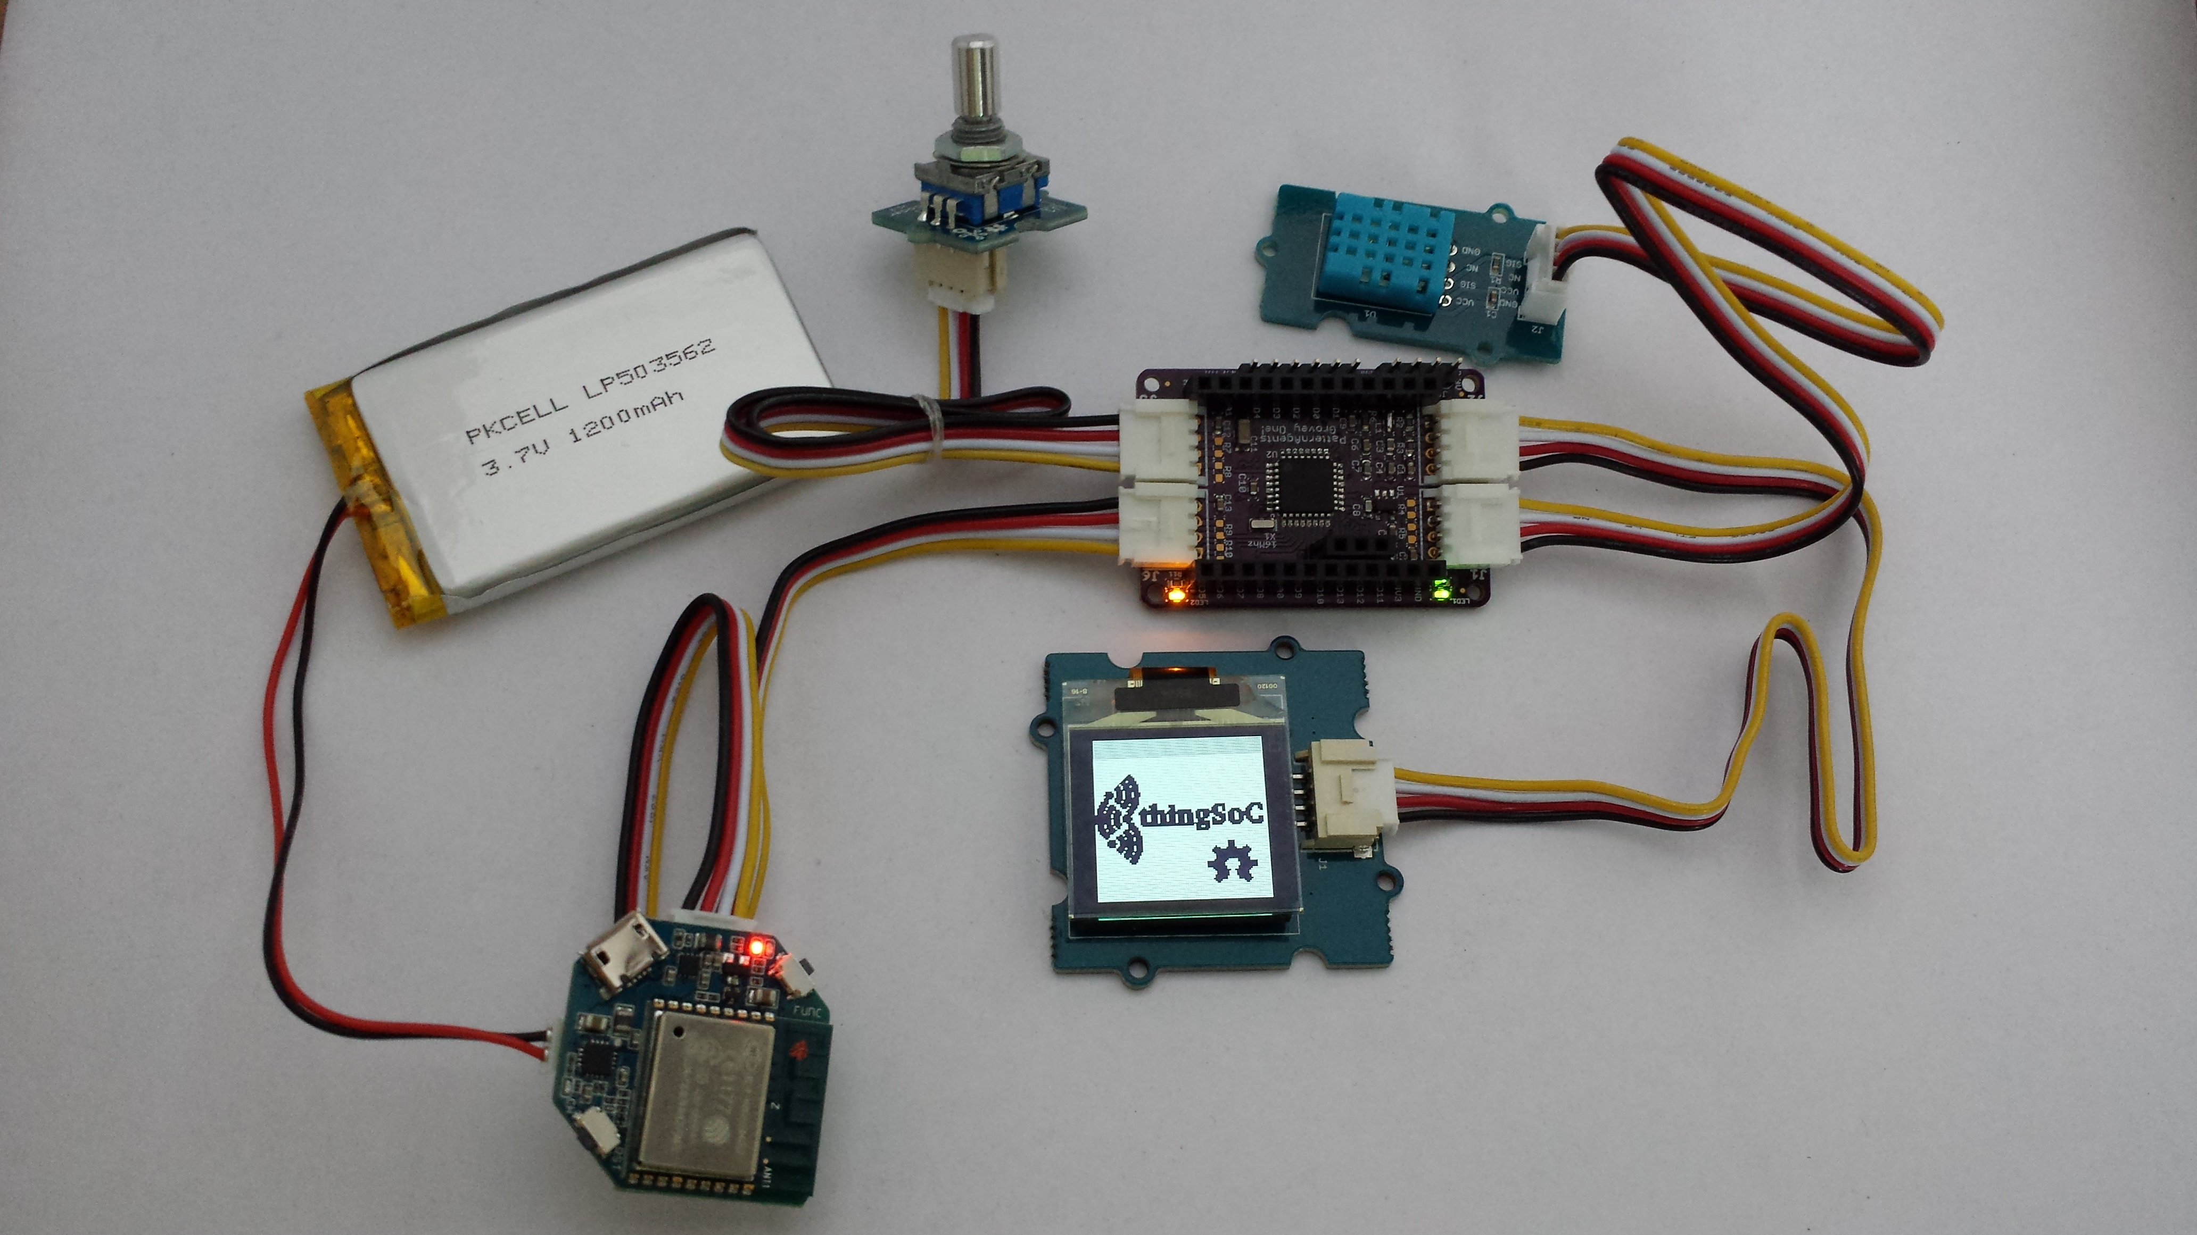

Adding Mikrobus Peripherals :
The TSOC_GROVEY_ONE board supports both Grove and Mikrobus peripherals.
1) Make sure to align the SQUARE/CUT edges of the Mikrobus board together to insure that
the polarity is correct. Push down evenly to seat the boards in the socket.
2) Note that the "stacking pins" are somewhat longer by design, and there will be some
extra space between the boards when using stacking connectors.
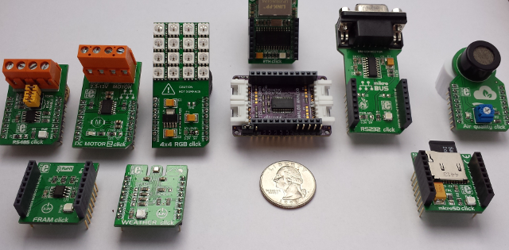
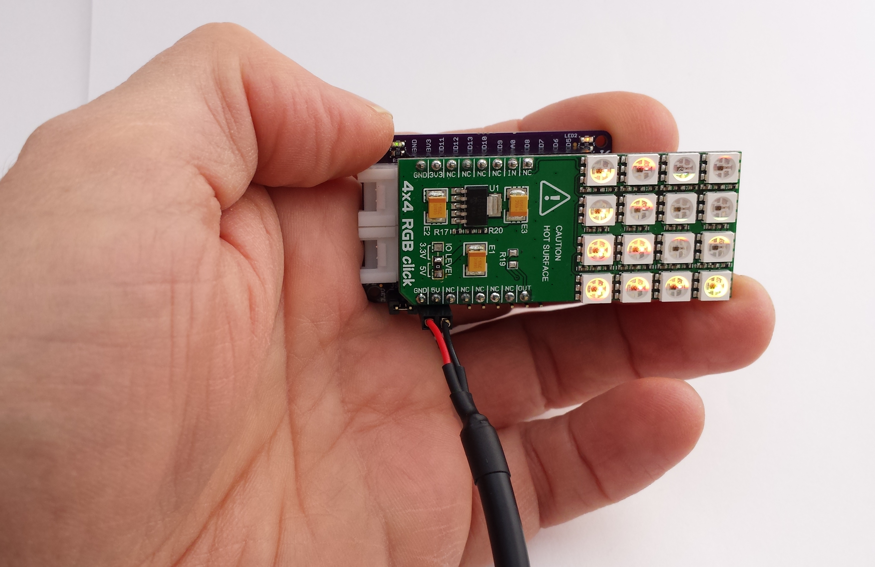

thingSoC® Grovey One Arduino Examples :

Default Firmware :

1) The Grovey One comes preloaded with the basic "Blink" project.
LED1 will blink slowly, indicating the sketch is running.
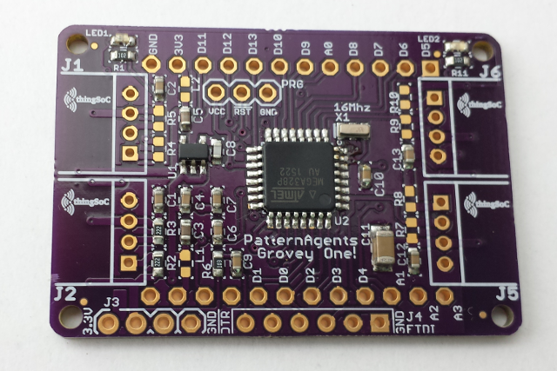
For more information and examples :

Complete documentation, including schematics, layouts, gerbers, and Bill of Materials (BOM) are available on the thingSoC website at :
https://github.com/thingSoC/TSOC_GROVEY_ONE/tree/master/TSOC_GROVEY_ONE

There is also a project Wiki available for asking questions and more information at :
https://github.com/thingSoC/TSOC_GROVEY_ONE/wiki

thingSoC® Grovey One Features :
The TSOC_GROVEY_ONE is a low cost, embeddable module featuring an ATMEGA328P device :
- Atmel ATMEGA328P (AVR) Processor
- 8 or 16 Mhz operation
- 3.3 Volt or 5.0 Volt operation
- 32 KiB FLASH memory
- 2 KiB SRAM
- 1 KiB EEPROM
- 3.3 Volt onboard voltage regulator
- 10-bit Analog to Digital Converter (8 Channels)
- Touch Sensing (8 Channels)
- SPI (1 Channel)
- I2C (1 Channel)
- UART (1 Channel)
- Power and USER LEDs
- thingSoC Compliant Module
- Mikrobus Compatible Module



